Case 5-A390-392-393-Asia-China-Warring States-Sword Accessories-Jade-475–221 BCE 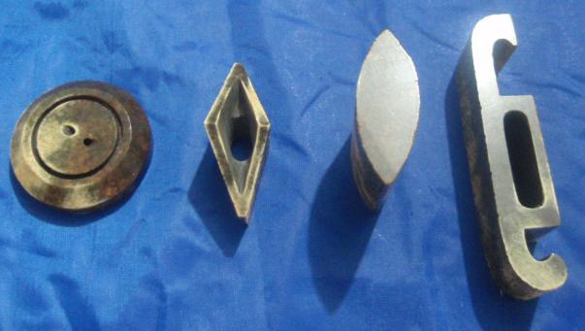
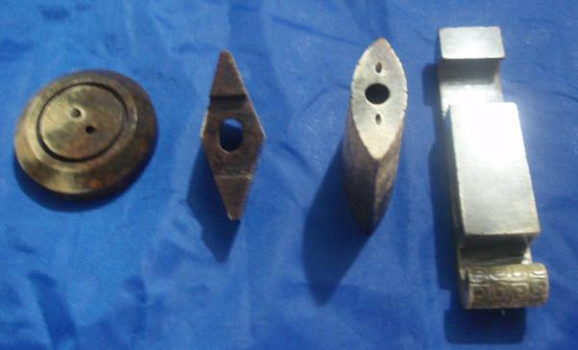
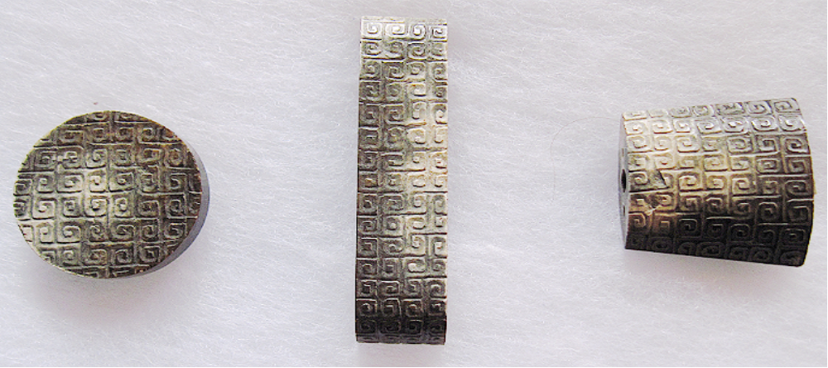
Figs/ 1-4. China-Warring States Period-Sword Accessories-Jade-475–221 BCE
Left Sword Chape. A fine archaic jade sword chape, the shaped rectangular carving worked with a design of rectangular stylized scrolls in shallow relief precisely centered around the central axis. The stone is of white jade with darker tones of areas of calcification attesting to its ancient age. The top edge with pierced fastening aperture for a leather scabbard base. Center: SCABBARD SLIDE
Right: Sword pommel of circular form, incised around the central aperture with cloud swirls, surrounded by a band of 'grain' motifs; the wei of rectangular form, carved to the top with a stylised beast mask

Case no.: 5
Accession Number: 390-393
Formal Label: China-Warring States Period-Sword Accessories-Jade-475–221 BCE
Display Description:
This highly rare, Warring States Period group of sword accessories consists of a sword pommel (shou), hilt guard (hsin) and sheath made of grey-white jade. Cloud motifs are carved in intaglio on all pieces making this a prized set.
LC Classification: NK1068
Date or Time Horizon: 475–221 BCE
Formal Label: China-Ming Dynasty-Sword Hilt, Slide and base-Nanjing-1368–1398
Display Description: This prized white Jade sword scabbard chape -slide, guide and hilt was awarded to a soldier or marine during the early Ming Dynasty at the capital Nanjing under the Hongwu Emperor, Zhu Yuanzhang (WG: Chu Yuan-Chang, reigned 1368–1398). As royal sword equipment, this complete jade sword set exemplifies the great value Zhu Yuanzhang placed on the élite officers of over one million troops (Wenxian 2008: 148–175). Similarly, Zhu Yuanzhang created a rural, civic society of demographically documented communities under a firm, secure central administrative structure freed from the intrigues of court eunuchs, who had previously opposed imperial control (Crawford 1961: 115-148). The third Ming Dynasty Emperor, Yongle, Zhu Di (WG: Chu Ti, reigned 1402 to 1424) had a treasure fleet built in Nanjing’s dockyards, which were the largest in the world. The fleet consisted of about 62 treasure ships with 27,800 men accompanied by about 200 military and support vessels with about 75,000 men (Ebrey, Walthall and Palais 2006: 271).
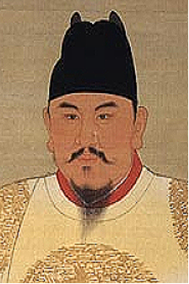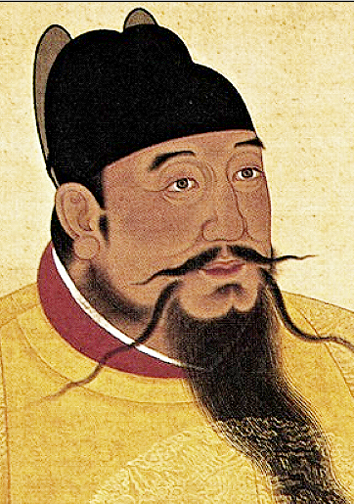
Fig. Hongwu Emperor, Zhu Yuanzhang (1368–98), hanging scroll, ink and color on silk. Size 270 x 163.6 cm. Located in National Palace Museum, Taipei. ( See National Palace Museum, Taipei. 1971: 108). After https://upload.wikimedia.org/wikipedia/commons/thumb/b/b8/Hongwu1.jpg/320px-Hongwu1.jpg
Fig. Yongle Emperor, Zhu Di (1402 to 1424), hanging scroll, ink and color on silk, 220 x 150 cm. Located in the National Palace Museum, Taipei. After https://upload.wikimedia.org/wikipedia/commons/thumb/f/fe/Anonymous-Ming_Chengzu.jpg/330px-Anonymous-Ming_Chengzu.jpg
LC Classification:
Date or Time Horizon: 1368–98
Geographical Area: Beijing
Map:
GPS coordinates:
Cultural Affiliation: Early Ming Empire
Medium: jade
Dimensions:
Weight:
Condition:
Provenance:
Discussion:
A391-392-393
Under the command of Zheng He (WG: Cheng Ho, 1371–1433 or 1435), this fleet traversed the South China Sea and the Indian Ocean to Calicut (in the state of Kerala in southern India on the Malabar Coast), to the port of Hormuz on the Arabian Peninsula in the Persian Gulf, and finally to what is now Kenya in east Africa (Hing 2010). It is intriguing to think that this sword apparatus accompanied a soldier or marine on these extensive voyages and that this equipment did finally arrive back safely to Nanjing.
References:
Crawford, Robert. 1961. “Eunuch Power in the Ming dynasty,” T'oung Pao, Second Series, (49: 3):115–148.
Dreyer, Edward L. 2007. Zheng He: China and the Oceans in the Early Ming Dynasty, 1405-1433. London: Pearson and Longman.

Ebrey, Patricia Buckley, Anne Walthall, and Kames B. Palais. 2006. East Asia: A Cultural, Social, and Political History. Boston: Houghton Mifflin Company.
Hing, Hui Chun. 2010. “Huangming Zuxun and Zheng He’s Voyages to the Western Oceans,” Journal of Chinese Studies, No. 51.
National Palace Museum, Taipei. 1971. Masterpieces of Chinese Portrait Painting in the National Palace Museum. Taipei: National Palace Museum.
Wenxian, Zhang. 2008. “The Yellow Register Archives of Imperial Ming China,” Libraries & the Cultural Record (43:2): 148–175.
Appendix:
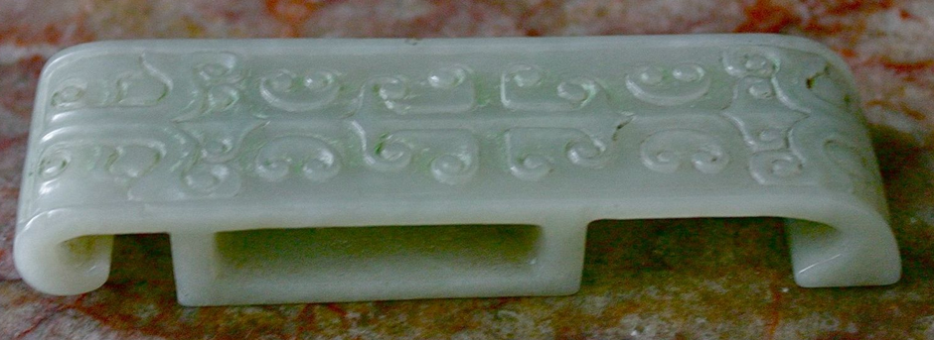
Chinese celadon grey jade finely carved sword slide, Ming Dynasty. The slide is 3 7/8" by 1 1/8". Carved in stylized mask and scroll carving.

Chinese Qing Dynasty Antique White Jade Sword Slide Size : 3.5in. X 1.05in.X 0.5in.

